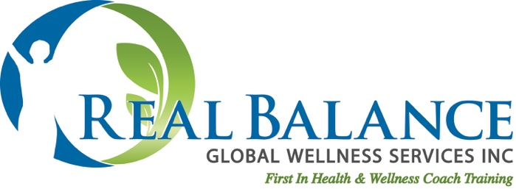

The Wheel of Life – How To Coach with This Tool

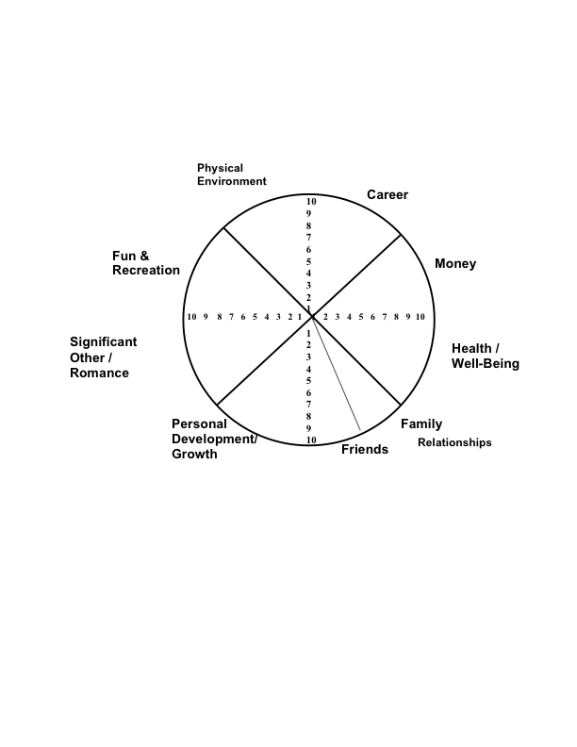The Wheel of Life is a very standard tool used throughout the field of coaching. A basic pie graph asking the client to rate their Satisfaction (Not Performance) in each area of their life, there are many variations as to the content of the areas. The idea is to help the client to become aware of the holistic nature of wellness/wellbeing. (continue on next page)

s

**Key Understandings of the Wheel of Life**

* The Wheel of Life is not a measure of anything precise. It is simply the subjective rating of the client’s level of satisfaction with that area of their life.
* It is not a rating of your client’s performance in an area of their life (how well they think they are doing).
* It is a snapshot of their life right now. This can and most likely will change over time. Having your client complete the Wheel of Life again later in their coaching journey, can be very helpful to identify areas of growth.
* It is important for the coach to not view the Wheel of Life as a way to identify “What’s wrong, and how can we fix it?” Think “What’s possible?”
* Coaching with the Wheel of Life is not about interpreting it; it is about using it as a catalyst for exploration with your client in a client-centered way.

**How to use the Wheel of Life in a Coaching Session**

* Instruct your client to rate each area of their life from 1-10 (1 being low and 10 being high) in terms of how satisfied they are in that area of their life today. Make the distinction that it is not about performance.
* You may have your client complete the Wheel of Life during a coaching session or complete it ahead of a session and bring it/send it to the coach. Many coaches find it very useful in the Foundation/Discovery Session.
* **Begin** by asking your client *“What was it like for you to complete the Wheel of life?”* or *“What was your experience completing the Wheel of Life?”*  Coach in response to what they share.
* **START WITH THE POSITIVE.** Use a Positive Psychology Approach and ask your client *“So, what were some of your* ***highest rated areas****?”*
* **Then explore.** For example: *“I see your rated family very high, a nine! Tell me, what about your family makes it a nine?* Doing this allows the client to share about their strengths and assets first, reminding them of what they have going for them as they begin their wellness journey. Your inquiry and interest also builds the Coaching Alliance and allows you and your client to celebrate this area of their life.
* **Next inquire** about the lower rated areas, inviting the client to share one they would like to talk about. *“Tell me about some of the areas you rated lower.”*  Then, request clarification – *“Tell me more about that area.”*
* **Never assume** that a low-rated area automatically is an area your client wants to or is ready to explore or to work on improving.
* **Explore.** For example *“I see you rated Friends at a 4. Tell me about that.”* Coach in response to what they share.
* **Do not launch into problem solving now.** You are helping your client to get a holistic picture of their life, including the challenges. You can reference their low-rated areas later in the coaching.
* **What you can do…**is to gently begin to help your client to consider improvement in an area by inquiring *“So what would it take to make that 4 a 5 or a 6?”* Do not ask the client what it would take to jump to a 10.
* **Ratings below a 4** can also be addressed by asking your client *“So, tell me what makes that rating a 3 instead of a 2 or a 1.”*
* **Ask your client** if they are noticing how any of the areas affect other areas, how interrelated they are. Clients often notice this themselves and open up discussion about that.
* **Ask your client to summarize** what they have learned about themselves by exploring the Wheel of Life and Coach in response to what they share.
* **Record** your client’s ratings of each area for future coaching use.

***Real Balance Health & Wellness Coach Training***

***www.realbalance.com***