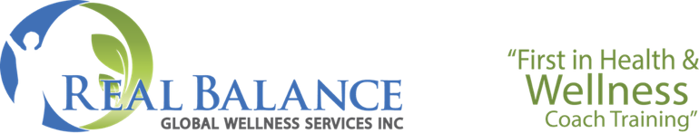

# 2023 CHECKLIST FOR Completing the Real Balance Foundation Class

**Complete the 40 in-class hours of interactive learning**

40 in-class hours

Make up missed classes (up to 3 classes) by:

* + - Listening to the class recording (in your class Forum on the Real Balance website)
    - Email your instructor for questions to answer for each missed class
    - Return your answers to your instructor and cc [Deborah@realbalance.com](mailto:Deborah@realbalance.com)
    - We recommend making up any classes by the end of month following the end of the class. Class recordings become archived.

Complete one in-class coaching review with your instructor. This is not scored

**Complete the Ethics/Legal Modules – Due 6 months from last day of class**

Read the ICF and NBHWC Ethics documents & NBHWC HIPAA documents

Listen to the Ethics & Legal Modules

Answer the questions for both modules

Return your answers to your instructor

*To access the Ethics/Legal Dropbox Folder in Dropbox:*

[*https://www.dropbox.com/scl/fo/obwyy0q8a0iu1rev0ua7e/h?dl=0&rlkey=5ml72r0jscbqd3weolpov2n2r*](https://www.dropbox.com/scl/fo/obwyy0q8a0iu1rev0ua7e/h?dl=0&rlkey=5ml72r0jscbqd3weolpov2n2r)

**Complete 6 one-hour buddy coaching sessions - Due 6 months from last day of**

**class**

6 sessions – a minimum of 30 minutes coaching and 30 minutes being coached

Complete a Buddy Coach Notes form for each session

To access the *Buddy Coach Guidelines* and *Buddy Coach Notes in Dropbox:*

<https://www.dropbox.com/scl/fo/a5z21is4fry0rjy014hcv/h?dl=0&rlkey=tr9aajx71hsdy1jjilkp4uxhr>

Submit all Buddy Coach Notes together via the Real Balance File Transfer process: <https://realbalance.com/file‐transfer>

**Complete the Case Study - Due 6 months from last day of class**

Six coaching sessions

To access the *Case Study Guidelines*, *Case Study Form* and *Case Study Rubric* in Dropbox:

This is scored. The passing grade is 75%

<https://www.dropbox.com/scl/fo/wy4vzwrzex1x8td7mgp8x/h?dl=0&rlkey=4jeyy39n3ntqcwrxynhdilpa6>

Submit your Case Study via the Real Balance File Transfer process: <https://realbalance.com/file‐transfer>

**Complete the Online Exam – 100 T/F,** **Multiple Choice Questions - Due 6 months from last day of class**

Exam passed

* + The link will be emailed to you by Deborah after the end of the class
  + The exam is open-book and is all multiple-choice questions
  + You can save your work and return to complete it later
  + You will get your score immediately after completing it
  + You may retake it if you do not have a passing score

**The Complete Dropbox folder for the 40 Hour Foundation Class:**

[**https://www.dropbox.com/scl/fo/5g1cf6elz9qar69rqhgpd/h?dl=0&rlkey=dz68xsoezsuqyeapzm1bg0v1t**](https://www.dropbox.com/scl/fo/5g1cf6elz9qar69rqhgpd/h?dl=0&rlkey=dz68xsoezsuqyeapzm1bg0v1t)