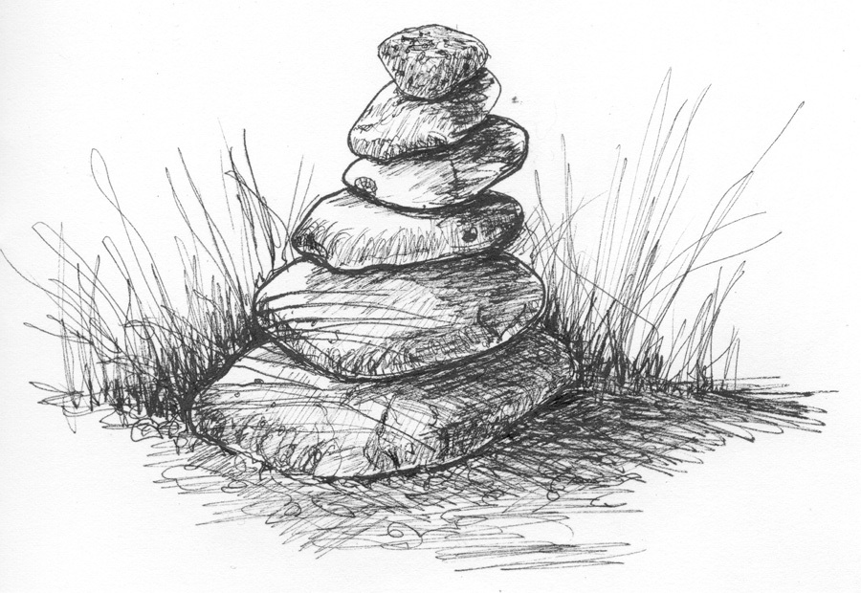
Milestones Reclaiming Tool

Historically milestones have been used to “mark the way” to one’s destination, often letting you know how far you have come, or how far you have to go. Use this tool to help you understand where you are at on your own reclaiming journey. Let them help you to be successful at getting to your destination.

List (in no particular order) personally meaningful/fun/rewarding activities that you used to do, but have not done since your health challenge appeared. (Examples: dancing, bicycling, having sex, visiting friends, air travel)
1.
2.
3.
4.
5.
6.
7.

Choose 5 activities from the list above and rate them using the following scale.
Activity 1. ______________________________________________________________
Doing this activity again will is:
Medically not possible A big challenge Possible Doable Likely
How important is reclaiming this activity as part of your life?
Not important Some what important Important Very important Extremely important
Notes:
Activity 2. ______________________________________________________________

Doing this activity again will is:
Medically not possible A big challenge Possible Doable Likely
How important is reclaiming this activity as part of your life?
Not important Some what important Important Very important Extremely important
Notes:
Activity 3. ______________________________________________________________
Doing this activity again will is:
Medically not possible A big challenge Possible Doable Likely
How important is reclaiming this activity as part of your life?
Not important Some what important Important Very important Extremely important
Notes:
Activity 4. ______________________________________________________________
Doing this activity again will is:
Medically not possible A big challenge Possible Doable Likely
How important is reclaiming this activity as part of your life?
Not important Some what important Important Very important Extremely important
Notes:
Activity 5. ______________________________________________________________
Doing this activity again will is:
Medically not possible A big challenge Possible Doable Likely
How important is reclaiming this activity as part of your life?
Not important Some what important Important Very important Extremely important
Notes:

Now, identify your three most important and doable activities.

1) _______________________________

2) _______________________________

3) _______________________________

Next list your first activity that you want to reclaim and identify three milestones that will be “markers” or steps along the way towards completing the task of doing that activity again.

Example:
1. Activity = bicycling
Milestones along the path toward my goal:
- Get in good enough shape to receive my doctor’s permission to bicycle
- Finish at least half of my rehabilitation sessions
- Find someone to bicycle with and set a date

Example:
2. Activity = hiking in mountains
Milestones along the path toward my goal:
- Walk one mile on flat ground
- Hike to top of a small hill
- Hike to top of challenging hill

My Milestones

Activity #1
Milestones along the path toward my goal: Date I reached it!
- ______________
- ______________
3. ______________
Notes:

Activity #2
Milestones along the path toward my goal: Date I reached it!
- ______________
- ______________
3. ______________
Notes:

Activity #3
Milestones along the path toward my goal: Date I reached it!
- ______________
- ______________
3. ______________
Notes:

